**Oving: Gietstalen tonnenlageraspotten**

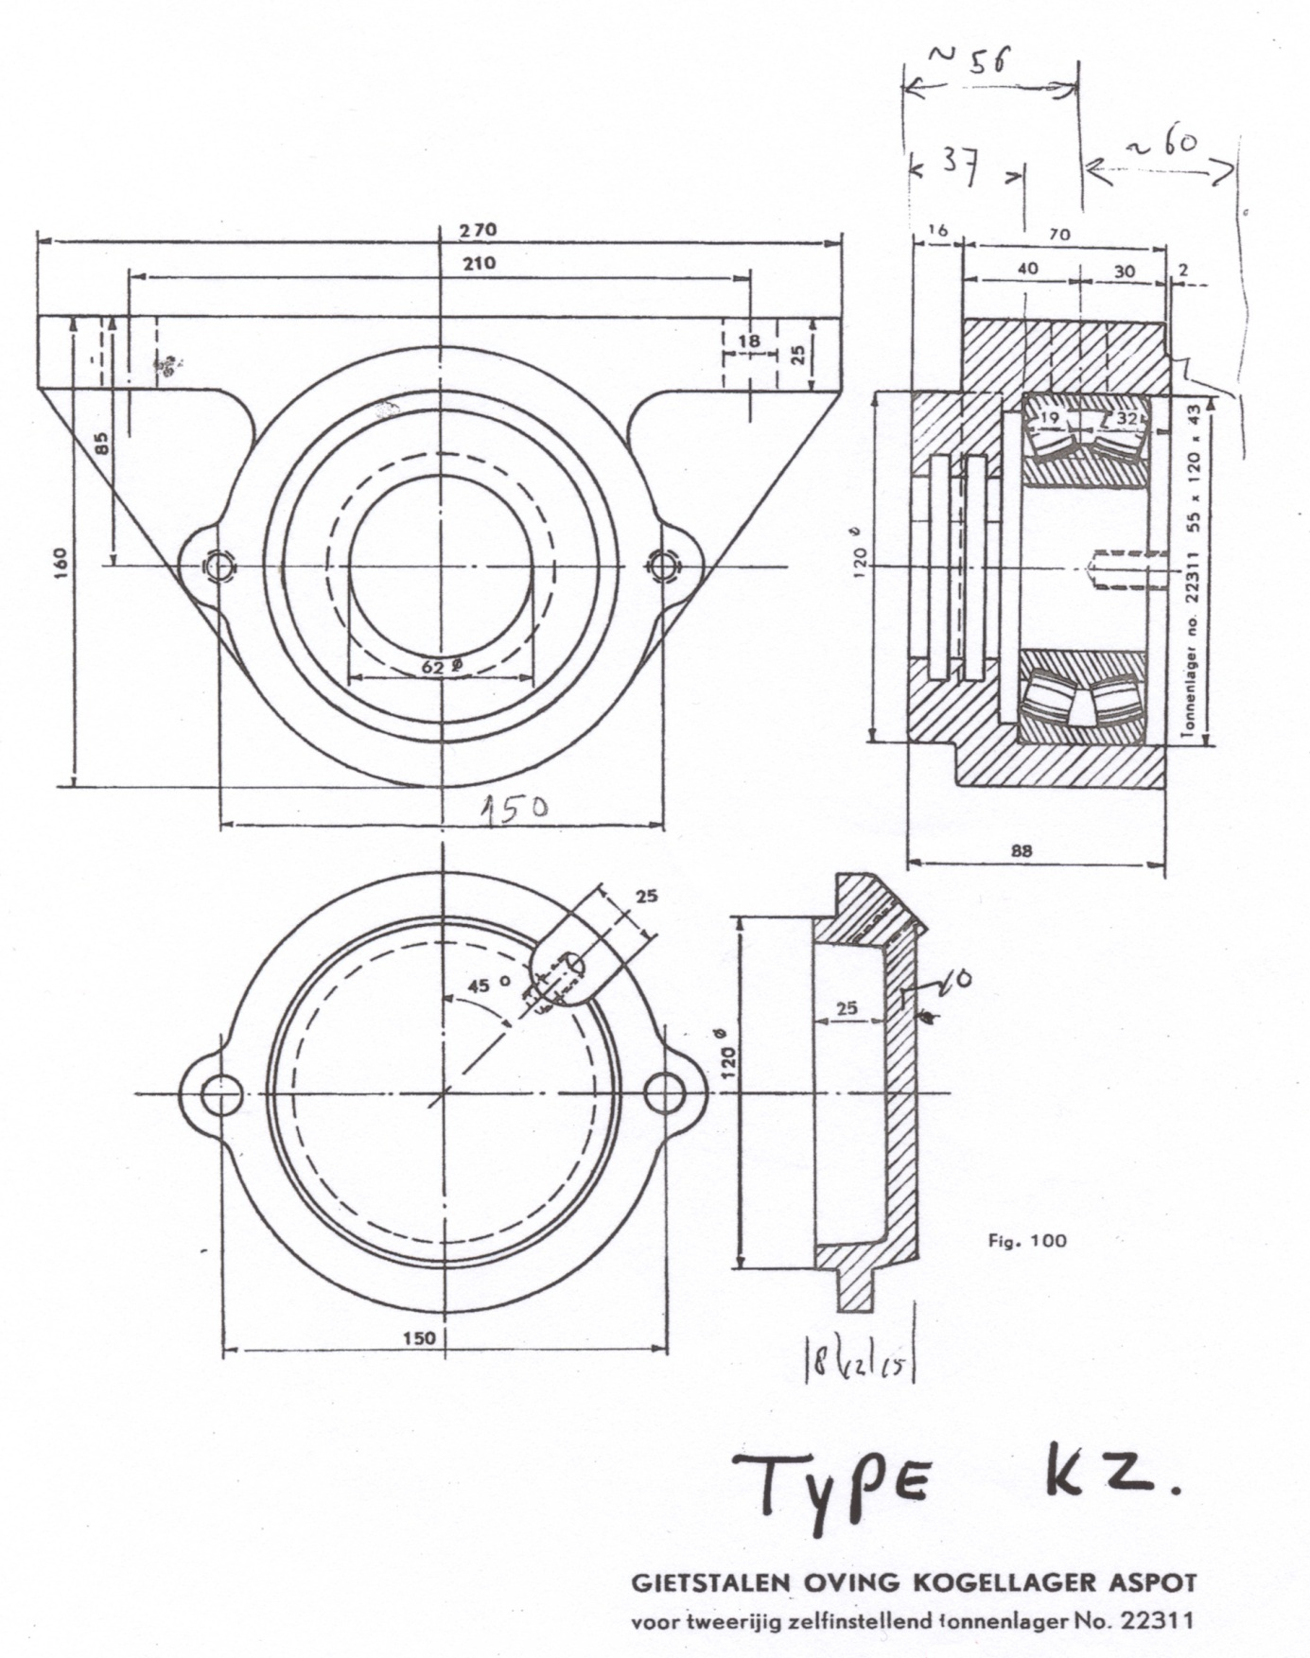

|  |  |  |
| --- | --- | --- |
| **Type** | **Astapdiameter in mm** | **Statische belasting per pot, in kg** |
| KZ 2213 | 65 | 2000 |
| KZ 2311 | 55 | 2850 |
| KZ 22213 | 65 | 10.200 |
| KZ 22311 | 55 | 15.600 |