Oving: Gietstalen kogellageraspotten

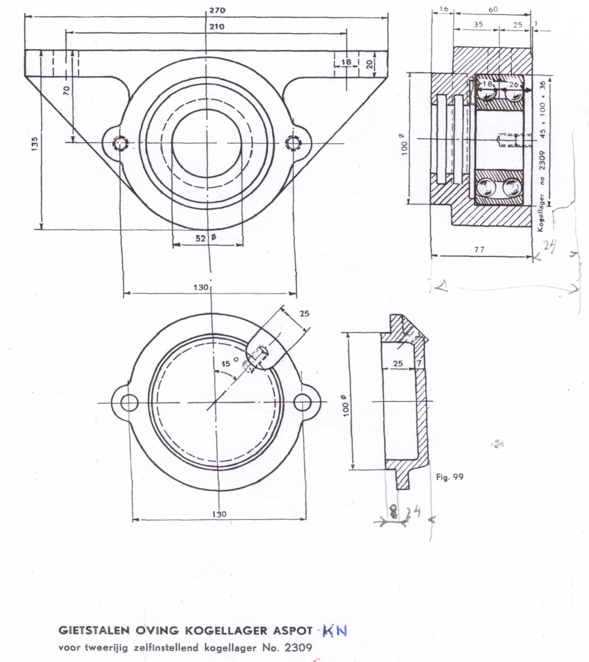

Type | Astapdiameter in mm | Statische belasting per pot, in kg
KN 2211 | 55 | 1250
KN 2309 | 45 | 2000
KN 2221 | 44 | 6800
KN 22309 | 45 | 10.000

